Vikat Associates, ►► #14, Ground Floor, Muthamma Layout, Kuvempunagar
Ban galore – 560 016
Tel: 9964710007/ e-mail: vikatassociates@gmail.com
WELCOME
COMPANY PROFILE

M/s VIKAT ASSOCIATES is registered with Government of India for Trading, Consulting & Turnkey Services in Construction Industry. The company has been promoted by 1 young & experienced construction industry professional, and firmly backed by a network of Industry Experts & Investors. Vikat Associates since its inception has received good amount of repeat business, as a direct result of its ‘Creating Excellence’ motto. The company has a well-built business model for a long & healthy existence in the Industry. We have structured the company into Primary Services and Extended Services for Customer Delight.
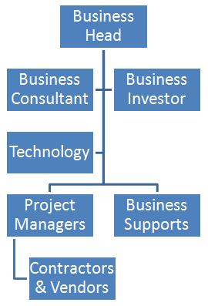
►►

Trading:
We provide supply solutions in

1. Glass
2. Hardware
3. Systems

Also, we can provide the installation & maintenance solutions for the above concerns.

TRADING

•Door
•Window
•Partition
•Cubicle
•Façade
•Sliding Folding Partition
• Automatic Doors
•Canopy, Staircase

Installation
•Doors
•Partitions
•Cubicles
•Façade
•Paneling
•Staircase / Railing
•Canopy / Skylight
•Automation

►►

Maintenance
•Cleaning
•Repair
•Refit
•Monthly Maintenance
•Quarterly Maintenance
•Half-yearly Maintenance
•Annual Maintenance

HARWARE DETAILS

Dorma, Ozone, Haffle

We have already had an AMC for the listed company below:-

•Outsourcing International Partners
Accenture
•VIRIDENT
•Voomet Interiors
•Paliath Interiors
• EXL Soft Solutions
•Northern Trust

We trust our Profile for your requirement and we look forward to a positive response from you.
Thanking you and assuring you of our best services at all times.
Thank You,

Ayappa.P
Managing Director
Vikat Associates
9964710007

